Business Process: Energy Profiler Online

Contact
Business Process Owner | Billing Operations - Billing Solutions
Subject Matter Expert(s) | Amanda De La Cruz, Katherine Martinez, Shannon Whitley
Key Contact | Maya Duarte
Key Role | Customer Services Representative II  Senior Customer Services Representative
Date Created | 5/5/2026

Business Process Overview
Energy Profiler Online (EPO) is a cloud-based Software as a Service (SaaS) solution from Schneider Electric that provides utility customers with access to load profiles, energy usage data, historical tracking, bill estimates, and related analytics. In SMUD’s process, the Strategic Account Advisor (SAA) receives our customer request, discusses EPO with our customer, and determines whether our customer wants to enroll. If so, the SAA completes Forms 2696 and 2831, obtains the required signatures, saves the completed forms, and sends them to Billing Exception Management (BEM).
BEM reviews the signed forms and sets up the account in both Itron Enterprise Edition (IEE) and Schneider. Once the setup is complete, a password is generated and sent to the SAA, who then provides the customer with login information and the Quick Start Guide. The customer completes a test login.
After BEM setup is complete, BEM notifies Billing Solutions (BS). The effective date will be the first business day following the last on cycle date unless otherwise noted. BS then applies the monthly fee via Installation Fact Operands and updates their Manual Billing Spreadsheet.
For ongoing maintenance, the Billing team may add, change, or cancel EPO charges by updating the billing systems, verifying the effective date, and including the required Device Location Notes.

Business Process Assumptions, Prerequisites, Dependencies
(Assumptions pertaining to the business process)
People | - Assumptions:  - The Strategic Account Advisor(SAA) fields our customer requests, discusses EPO, and determines whether our customer wants to enroll.  - Billing Exception Management(BEM) and Billing Solutions(BS) are available to complete their portions of the setup and billing process.  - Staff understand the required forms, system steps, and documentation expectations.  - Prerequisites:  - Our customer request has been received and discussed with the customer.  - Forms 2696 and 2831 have been completed, signed, and saved before being sent to Billing Exception Management.  - Dependencies:  - The process depends on coordination between the SAA, BEM, and BS.  - Customer participation is required for signatures and the test login.
Process | - Assumptions:  - The customer is eligible for EPO enrollment.  - The standard process flow is followed from enrollment through setup, billing, and maintenance.  - The effective date is the following business day after the last on cycle date unless otherwise noted.  - Prerequisites:  - Forms 2696 and 2831 must be completed, signed, and saved.  - Billing Exception Management (BEM) must receive the forms before setup can begin.  - Dependencies:  - Enrollment depends on the Strategic Account Advisor (SAA) completing the customer-facing portion of the process.  - Billing setup depends on BEM reviewing the forms and completing account setup in Itron Enterprise Edition (IEE) and Schneider.  - Billing application depends on Billing Solutions applying the monthly fee and updating the Manual Billing Spreadsheet.  - Ongoing maintenance depends on the ability to add, change, or cancel EPO charges and update Device Location Notes.
Technology | - Assumptions:  - IEE, Schneider, and the billing systems are available and functioning properly.  - The systems contain accurate account information and support password generation, login access, and charge application.  - Prerequisites:  - The account must be set up in both IEE and Schneider before the customer receives login information.  - The billing systems must be ready to apply the fee and maintain billing records.  - Dependencies:  - The process depends on Schneider, IEE, and billing system integration.  - It also depends on the ability to update Device Location Notes and the Manual Billing Spreadsheet.

Process Flowchart
Energy Profiler Online Process Mapping As Is.vsdx

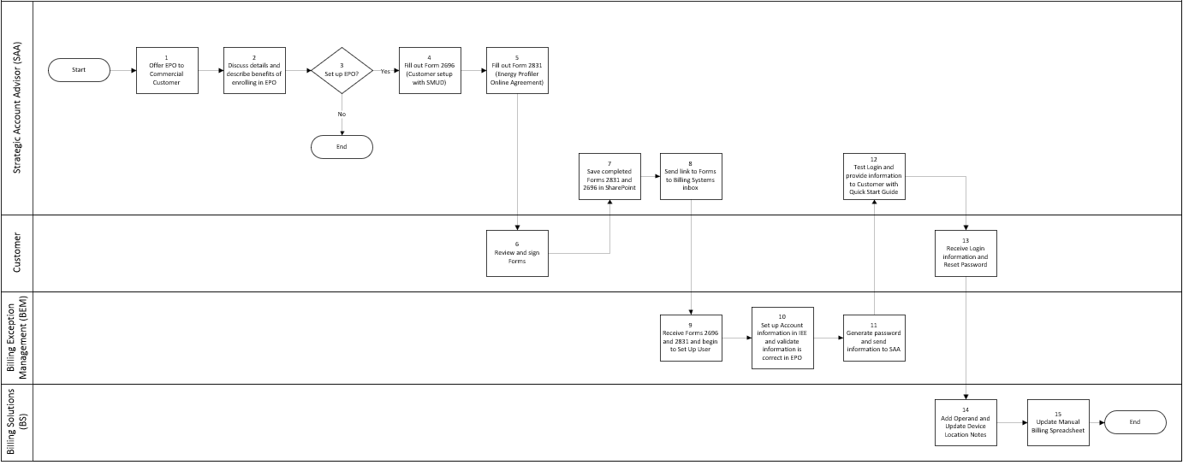

Task Description
Id | Task Description | Procedure
1 | Offer EPO to commercial customer | Strategic Account Advisor (SAA) offers Energy Profiler Online (EPO) to the customer.
2 | Discuss EPO details and benefits | SAA discusses the details and benefits of enrolling in EPO.
3 | Set up EPO? | SAA determines whether the customer wants to enroll in EPO.
4 | Complete Form 2696 | SAA completes Form 2696 for customer setup with SMUD.
5 | Complete Form 2831 | SAA completes Form 2831, the EPO Agreement.
6 | Review and sign forms | Required parties review and sign Forms 2696 and 2831.
7 | Save completed forms | SAA saves the completed Forms 2831 and 2696 in SharePoint
8 | Send forms to Billing Systems inbox | SAA sends the link to the completed forms to Billing Exception Management (BEM) via Billing Systems inbox.
9 | Receive forms and begin setup | BEM receives Forms 2696 and 2831 and begins to set up the user.
10 | Set up account information in IEE and validate EPO | BEM sets up account information in Itron Enterprise Edition and validates that the information is correct in EPO.
11 | Generate password and send information to SAA | BEM generates a password and sends the information to the SAA.
12 | Test login and provide Quick Start Guide | Strategic Account Advisor (SAA) tests the login and provides the customer with login information and the Quick Start Guide.
13 | Receive login information and reset password | Customer receives the login information and resets the password.
14 | Add Operand and Update Device Location Notes | Billing Solutions (BS) team adds charges to the bill after setup is fully complete and updates Device Location Notes.
15 | Update Manual Billing Spreadsheet | BS team updates the Manual Billing Spreadsheet.

Business Rules
Id | Event Name | Business Rules
2 | Discuss details and describe benefits of enrolling in EPO | The SAA explains the Energy Profiler Online (EPO) offering and its benefits to the customer.
3 | Set up EPO | If the customer wants to enroll, the SAA completes the required forms and obtains signatures before sending them to Billing Exception Management (BEM).
4 | Fill out Form 2696 | Form 2696 is required as part of the customer setup with SMUD.
5 | Fill out Form 2831 | Form 2831 is required to add a new Energy Tracking Fee.
6 | Review and sign Forms | The completed forms must be reviewed and signed before they are saved and sent for processing.
7 | Save completed Forms 2831 and 2696 in SharePoint | The completed forms must be saved before being sent to BEM.
9 | Receive Forms 2696 and 2831 and begin to Set Up User | BEM must receive the forms and begin the setup process.
14 | Add Operand and Update Device Location Notes | Charges are added only after setup is fully complete.
15 | Update Manual Billing Spreadsheet | Billing Solutions updates the Manual Billing spreadsheet.

Event | Legal Requirements, Rules, and Regulations  Legal documents/ procedures/ requirements to be fulfilled before/at the specified event.
Id | Event | Legal Requirements, Rules and/or Regulations
 |  | N/A

Pain Points and Improvement Opportunities
- Multiple handoffs between roles: The process moves from the Strategic Account Advisor (SAA) to Billing Exception Management (BEM) to Billing Solutions (BS), which can create delays, rework, or missed communication if ownership is not clear.
- Manual form handling: Forms 2696 and 2831 must be completed, signed, saved, and sent manually, which introduces the risk of missing information, incorrect signatures, or version control issues.
- System coordination across platforms: The process relies on both Itron Enterprise Edition (IEE) and Schneider being updated correctly, so inconsistent data between systems could cause setup errors impacting customer experience and driving increased inquiries to SMUD.
- Effective date sensitivity: The billing effective date is tied to the next business day after the last on cycle date unless otherwise noted, so timing errors could lead to inaccurate charges or customer disputes.
- Manual billing updates: BS updates the monthly fee via Installation Fact Operands and Manual Billing Spreadsheet, which creates potential for manual entry errors.
- Customer login and onboarding friction: The customer must complete a test login and reset the password, so delays in credential delivery or unclear instructions could affect adoption and customer experience.
- Opportunity for process simplification: Standardizing intake, automating form routing, and reducing manual spreadsheet updates could improve cycle time and reduce errors.
- Opportunity for better customer experience: Providing clearer customer guidance, faster login setup, and more streamlined onboarding materials could improve enrollment success and reduce support burden.
- Opportunity for stronger system integration: better integration between Schnieder, IEE, and billing workflows could reduce duplicate entry and improve data consistency.

Departments impacted by process change

Department | Type of Change(s) | Action Required
Billing
Commercial Delivery

Supporting Documentation
(Any subsequent documentation in support of this business process (i.e. business requirements, technical specs, etc.) shall be summarized in the following table.)
Document Type | Link
Business Procedures | Energy Profiler Online (EPO) Setup.aspx
Business Procedures | Energy Profiler Online Missing Data Process.pdf
Business Procedures | Energy Tracking Fee EPO.pdf
Business Process Overview | EPO Price Update Testing.docx
Process Map | Energy Profiler Online Process Mapping As Is.vsdx

Business Blueprint Amendments

Any subsequent changes to this business process blueprint after the official document approval shall be summarized in the following table. This document must be reprinted and signed by the authorized representatives.
Version | Author | Description of Change | Approval (Name) | Date
1.0 | Joshua Dunn | Initial Draft | Maya Duarte | 5/5/2026

